1 ) Execute all the templates shown in the video.

AWS Provider Example
Install Terraform on EC2 (Amazon Linux)
Step 1: Install yum-utils
sudo yum install -y yum-utils
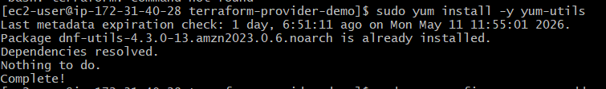

Step 2: Add HashiCorp Repository
sudo yum-config-manager --add-repo https://rpm.releases.hashicorp.com/AmazonLinux/hashicorp.repo

Step 3: Install Terraform
sudo yum -y install terraform
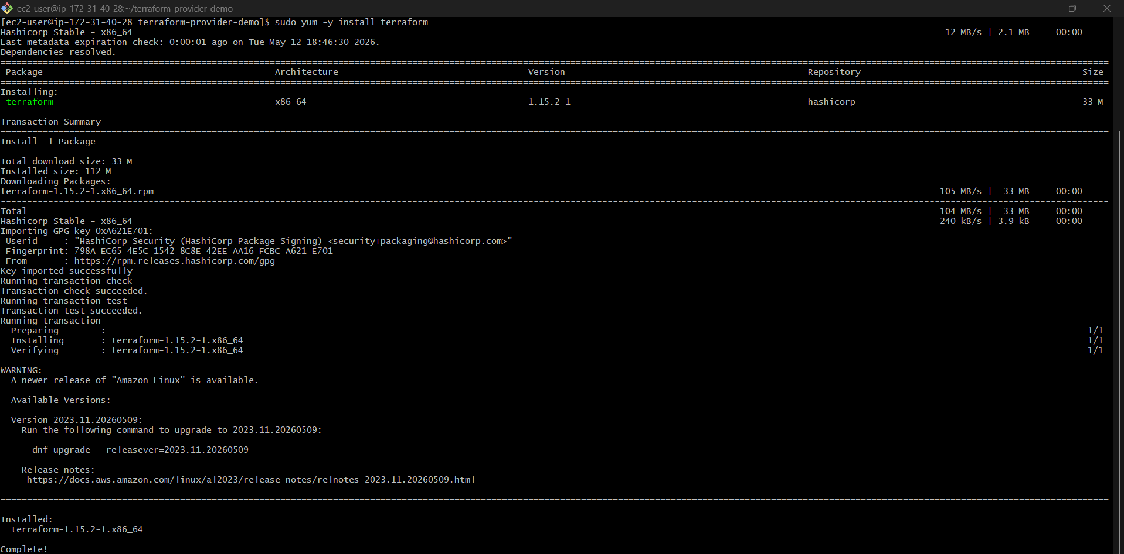

Step 4: Verify Installation
terraform -version
Example output:
Terraform v1.8.x
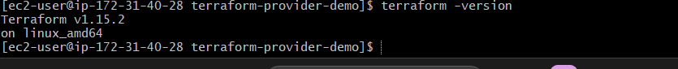

Example on Linux/Ubuntu/Amazon Linux:
mkdir terraform-provider-demo
cd terraform-provider-demo
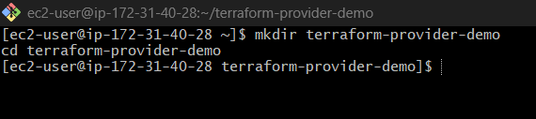
This creates:
~/terraform-provider-demo
Inside that folder, create the main.tf file.
Example:
vi main.tf
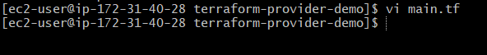

Paste:
terraform {
required_providers {
aws = {
source = "hashicorp/aws"
version = "~> 5.0"
}
}
}

provider "aws" {
region = "ap-south-1"
}
resource "aws_instance" "myec2" {
ami = "ami-0f58b397bc5c1f2e8"
instance_type = "t3.micro"
tags = {
Name = "Terraform-Server"
}
}
Save and exit:
:wq
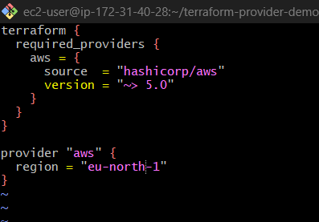
Then run:
terraform init
Terraform will automatically create:
terraform-provider-demo/
├── main.tf
├── .terraform/
├── .terraform.lock.hcl
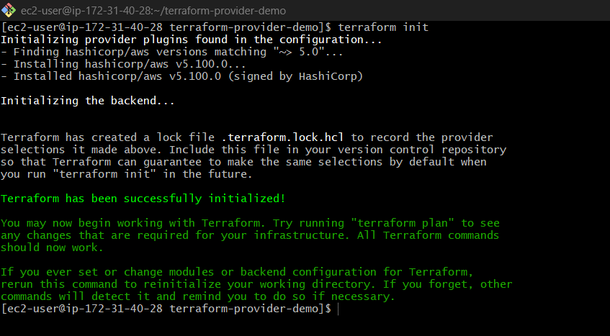

What terraform init Does
1. Downloads Provider Plugins
Downloads AWS provider from Terraform Registry.
hashicorp/aws

2. Creates .terraform Directory
Terraform stores provider binaries here.
.terraform/

3. Creates Lock File
.terraform.lock.hcl
Locks provider versions.

4. Initializes Backend
Prepares Terraform state management.
Default backend:
terraform.tfstate

Then Run
Validate
terraform validate
Checks syntax.
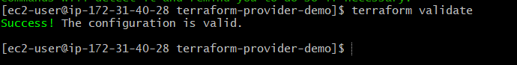

Plan
terraform plan
Shows execution preview.
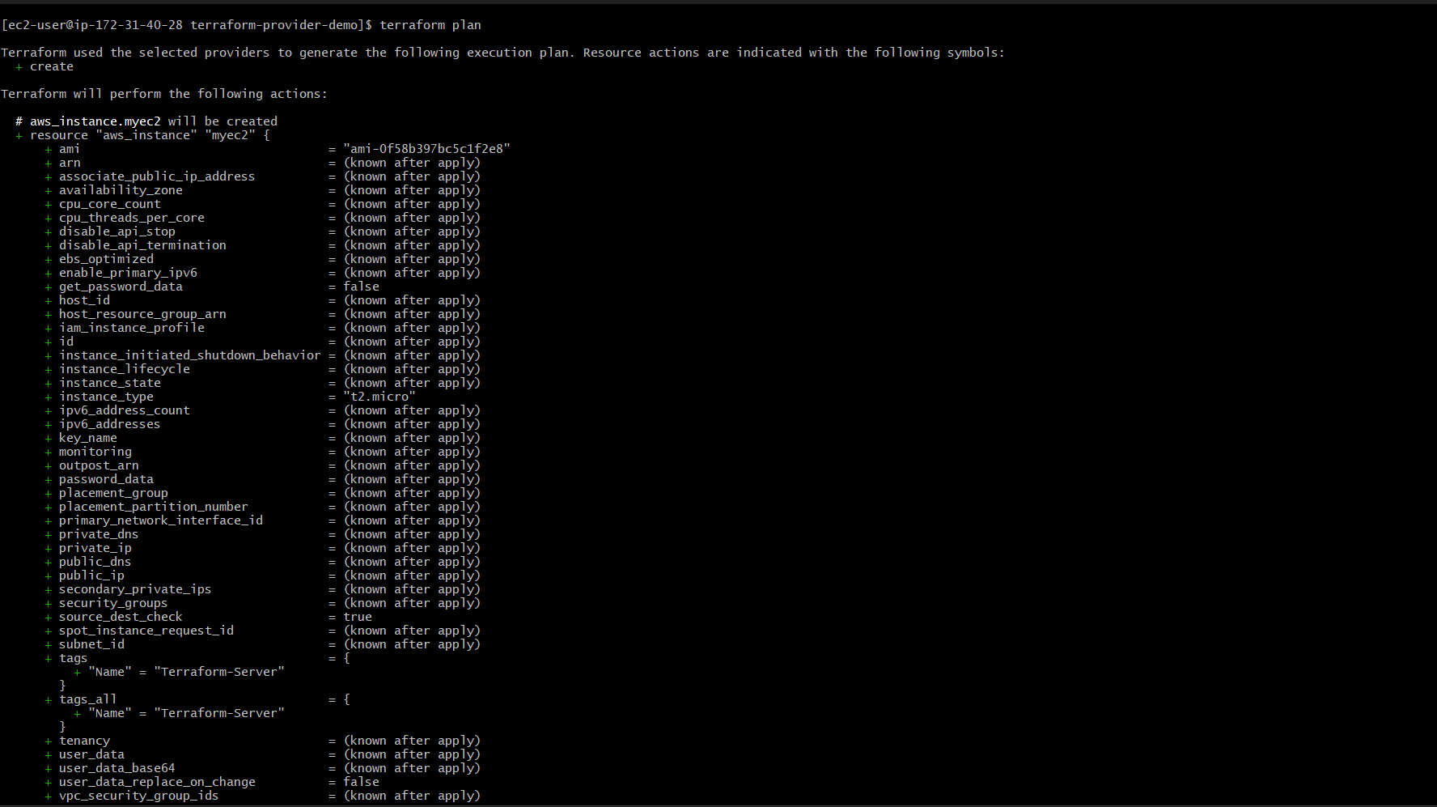
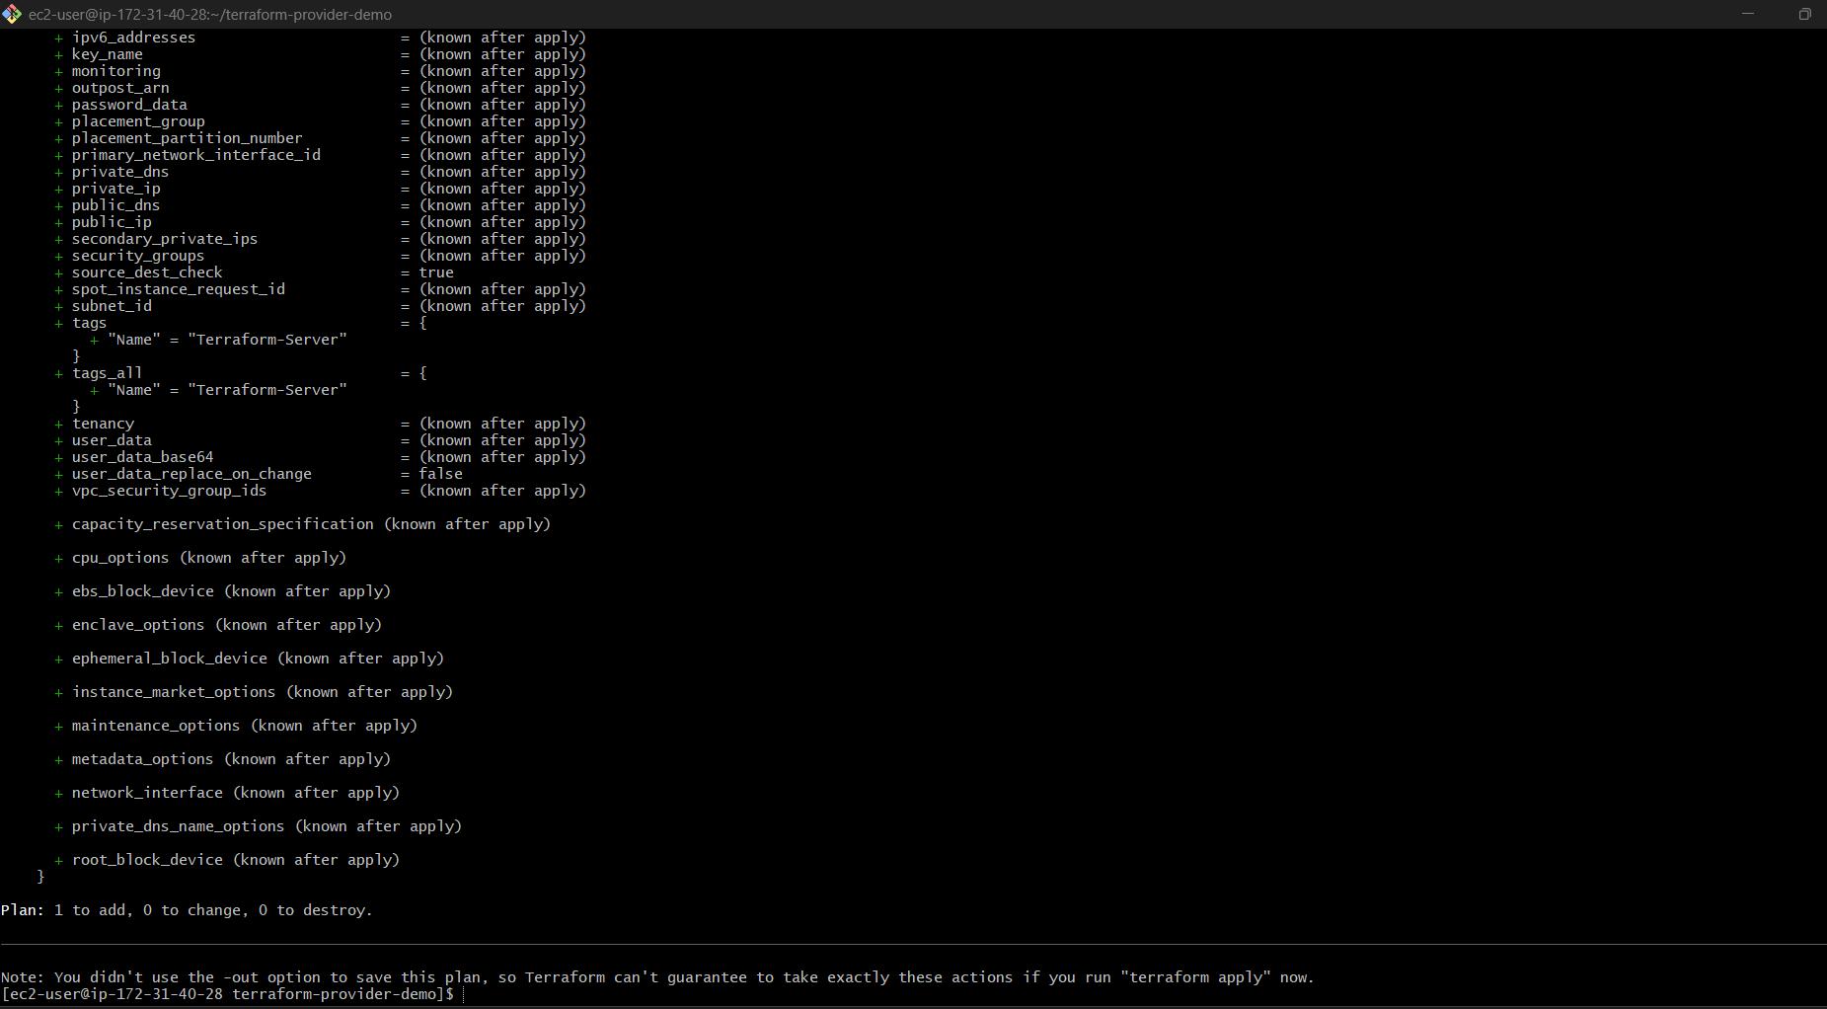

Apply
terraform apply
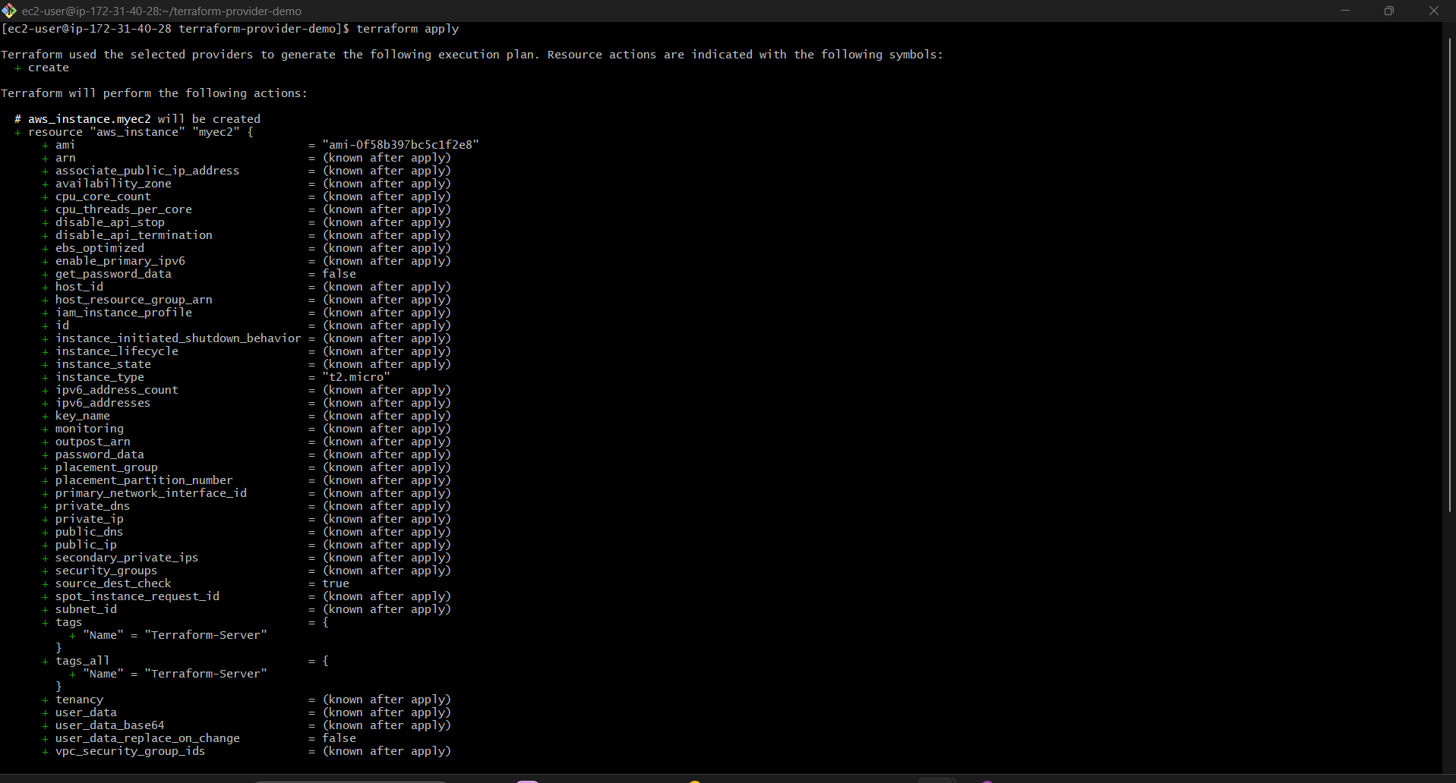
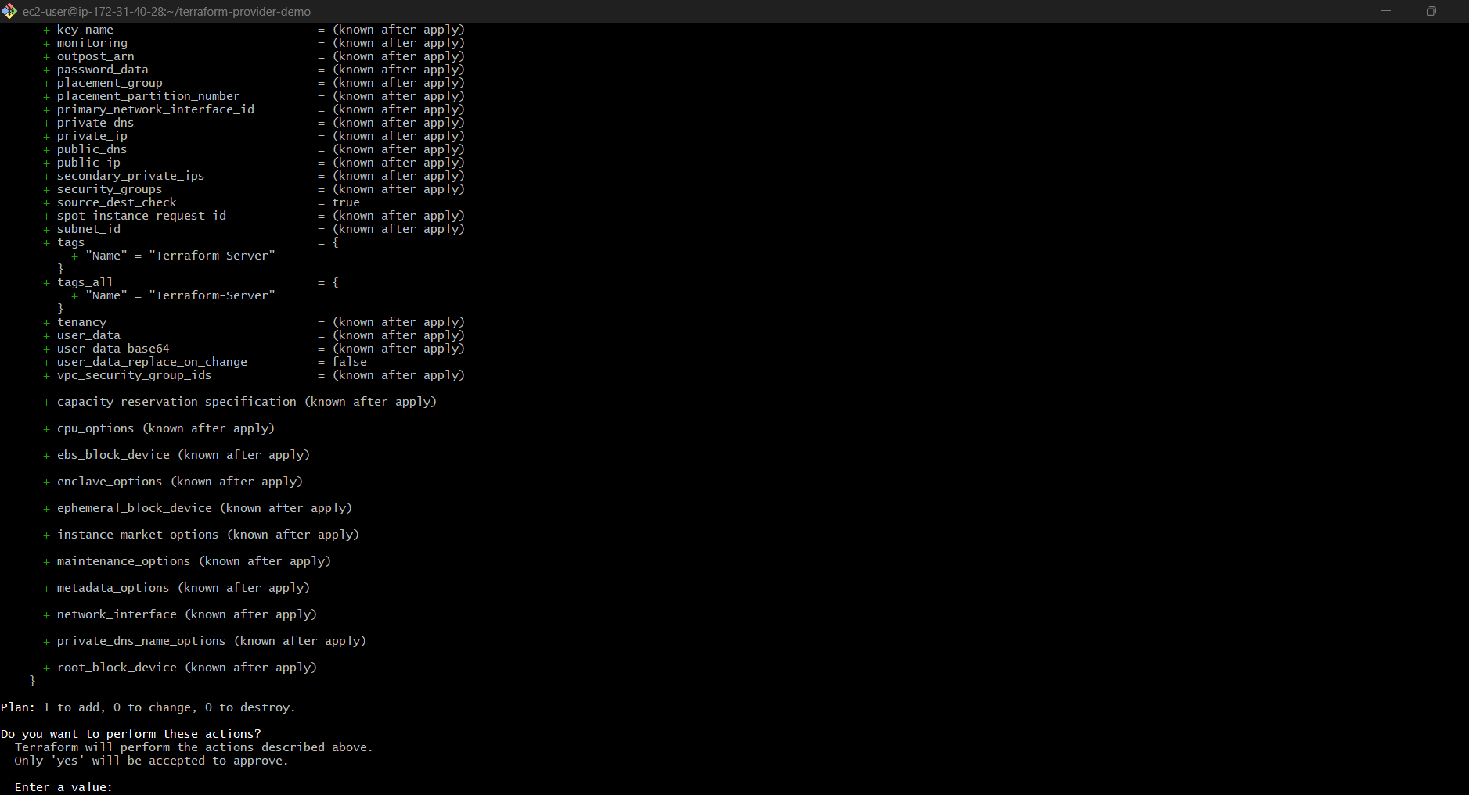
Type:
Yes
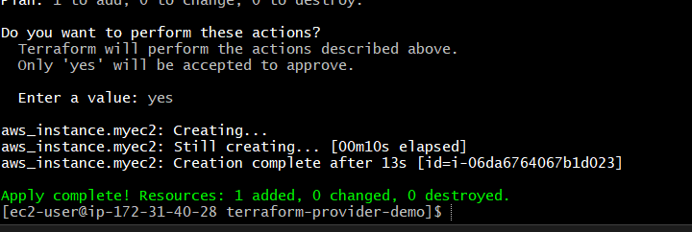

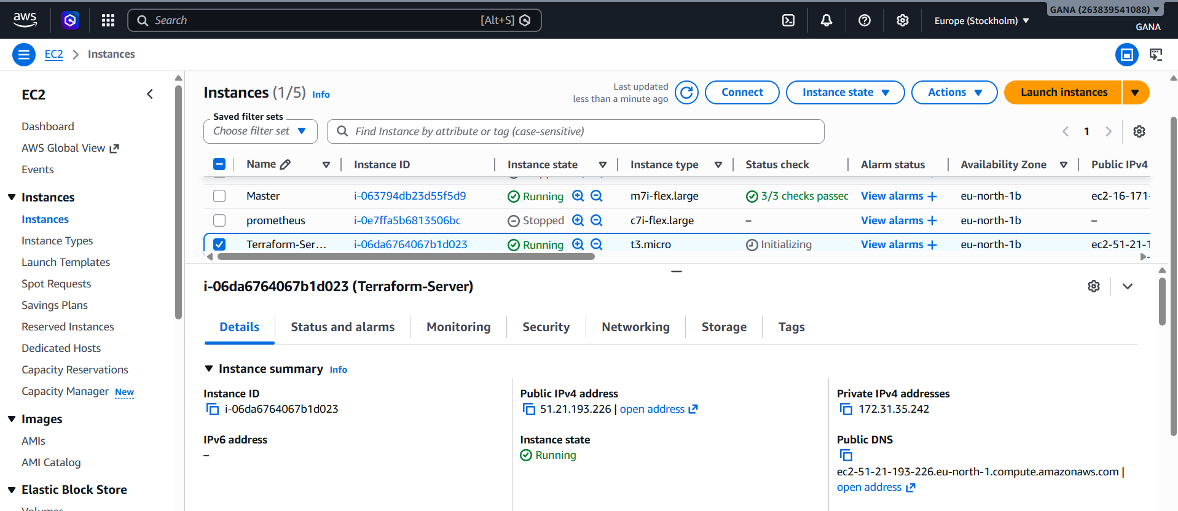

Destroy
terraform destroy
Deletes infrastructure created by Terraform.
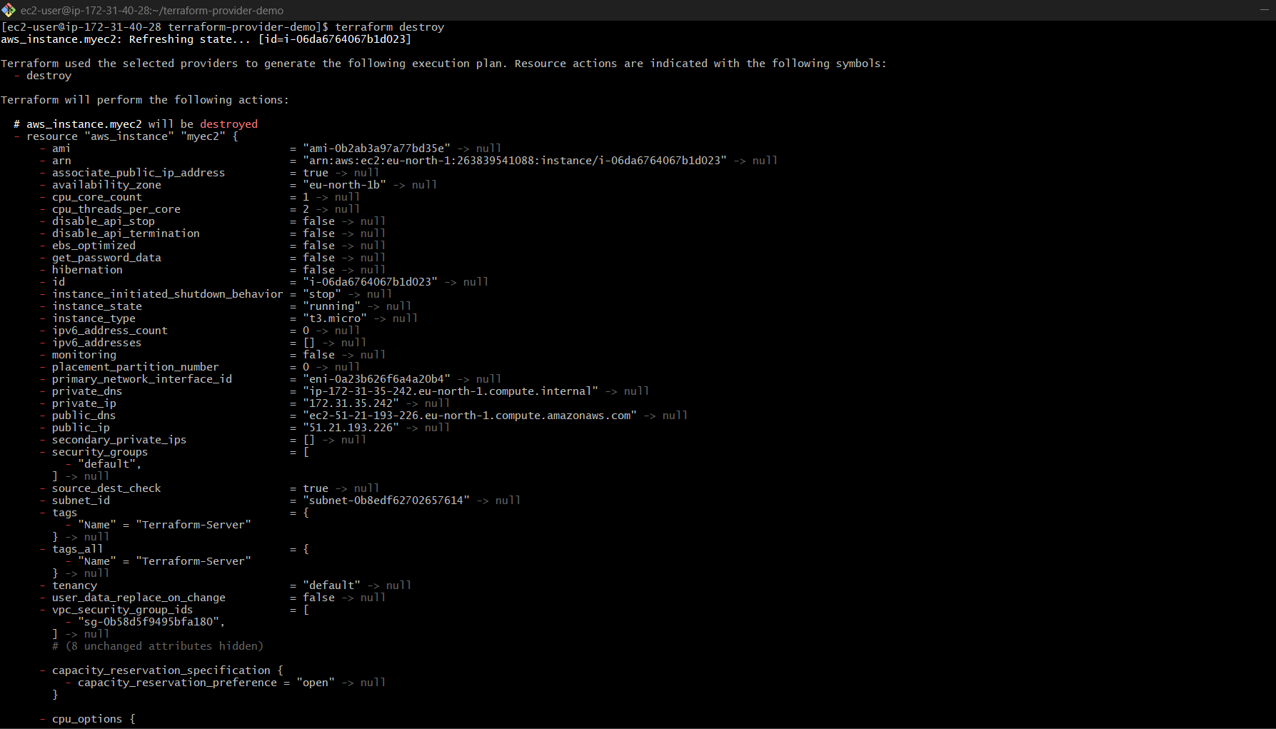
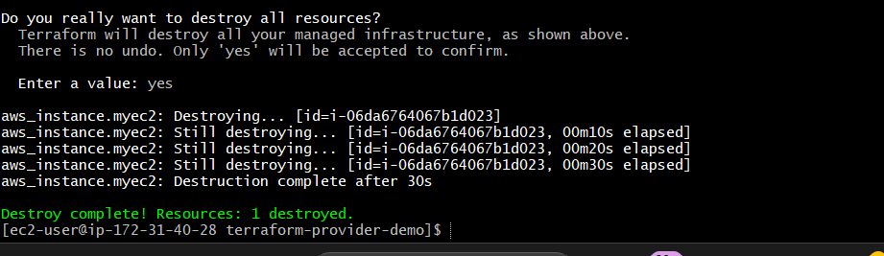
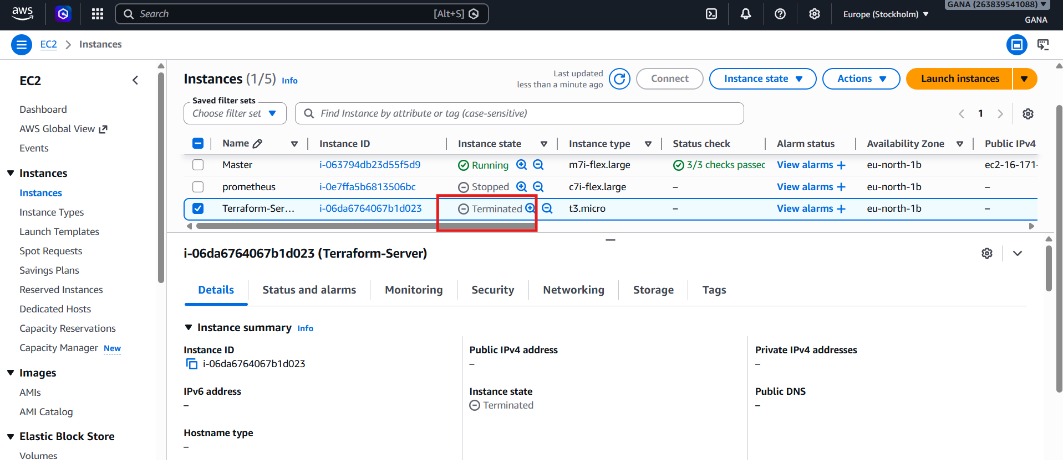

Then continue:
Validate
terraform validate
Plan
terraform plan
Apply
terraform apply
Type:
yes
Destroy
terraform destroy

Real-Time Example Flow
mkdir terraform-provider-demo
cd terraform-provider-demo
vi main.tf
terraform init
terraform validate
terraform plan
terraform apply
terraform destroy

Important
Before using AWS Provider, configure AWS credentials:
aws configure
Enter:
AWS Access Key ID
AWS Secret Access Key
Region = ap-south-1
Without credentials, Terraform cannot connect to Amazon Web Services.

Terraform Lifecycle Rules

A) create_before_destroy

Open file:
vi main.tf
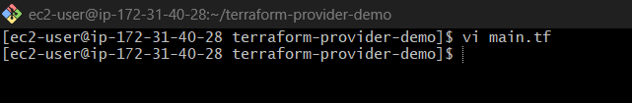
Complete example:
terraform {
required_providers {
aws = {
source = "hashicorp/aws"
version = "~> 5.0"
}
}
}
provider "aws" {
region = "eu-north-1"
}
resource "aws_instance" "myec1" {
ami = "ami-0b2ab3a97a77bd35e"
instance_type = "t3.micro"
lifecycle {
create_before_destroy = true
}
tags = {
Name = "Terraform-Server"
}
}

Save and exit:
:wq

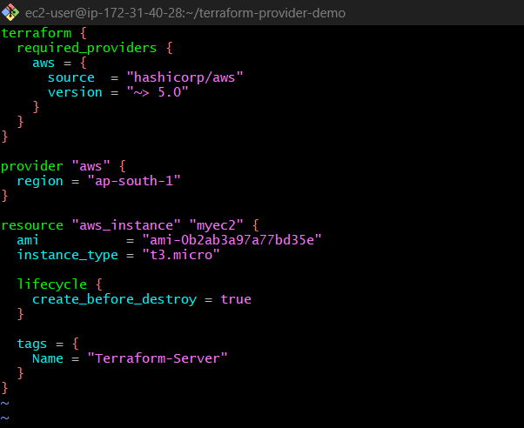
Then run:
Validate
terraform validate
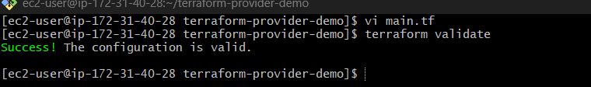

Plan
terraform plan
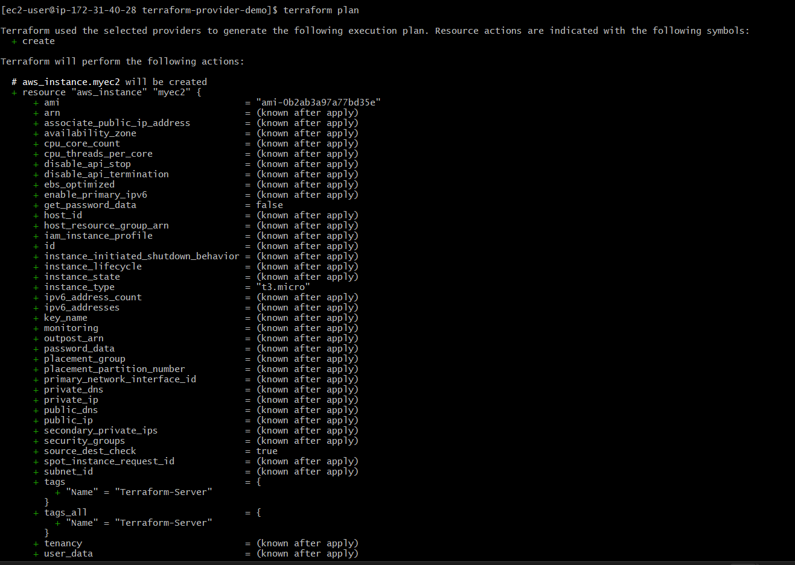
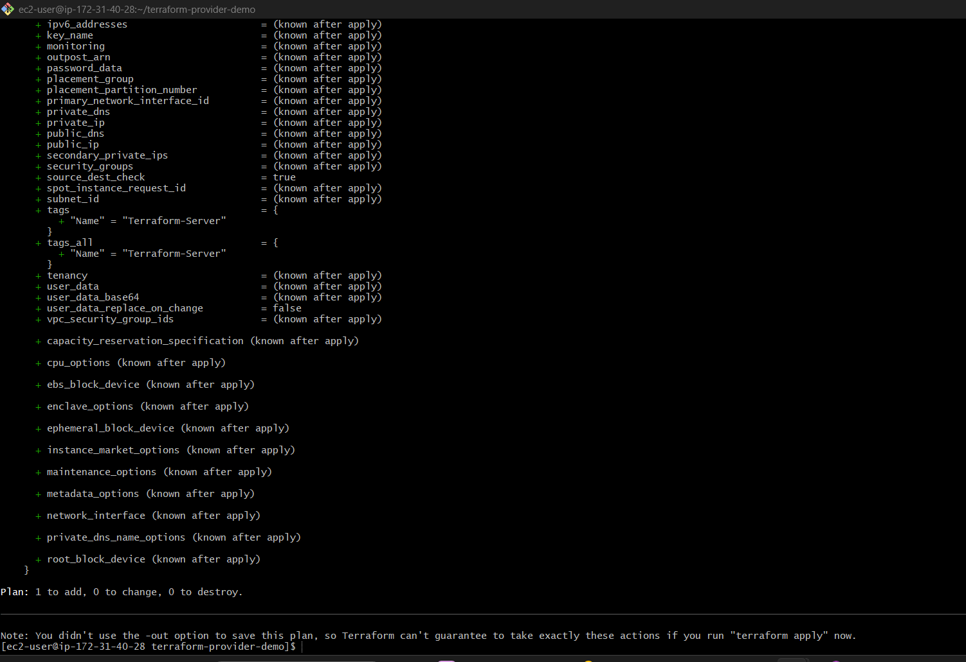

Apply
terraform apply
Type:
yes
Terraform will create EC2 instance with lifecycle rule enabled in Amazon Web Services.

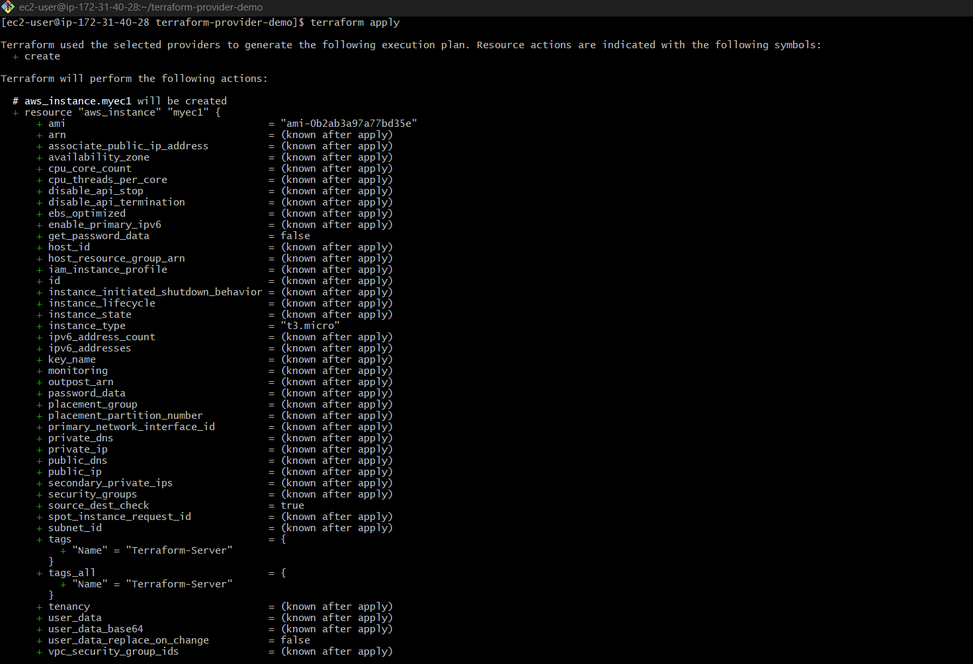
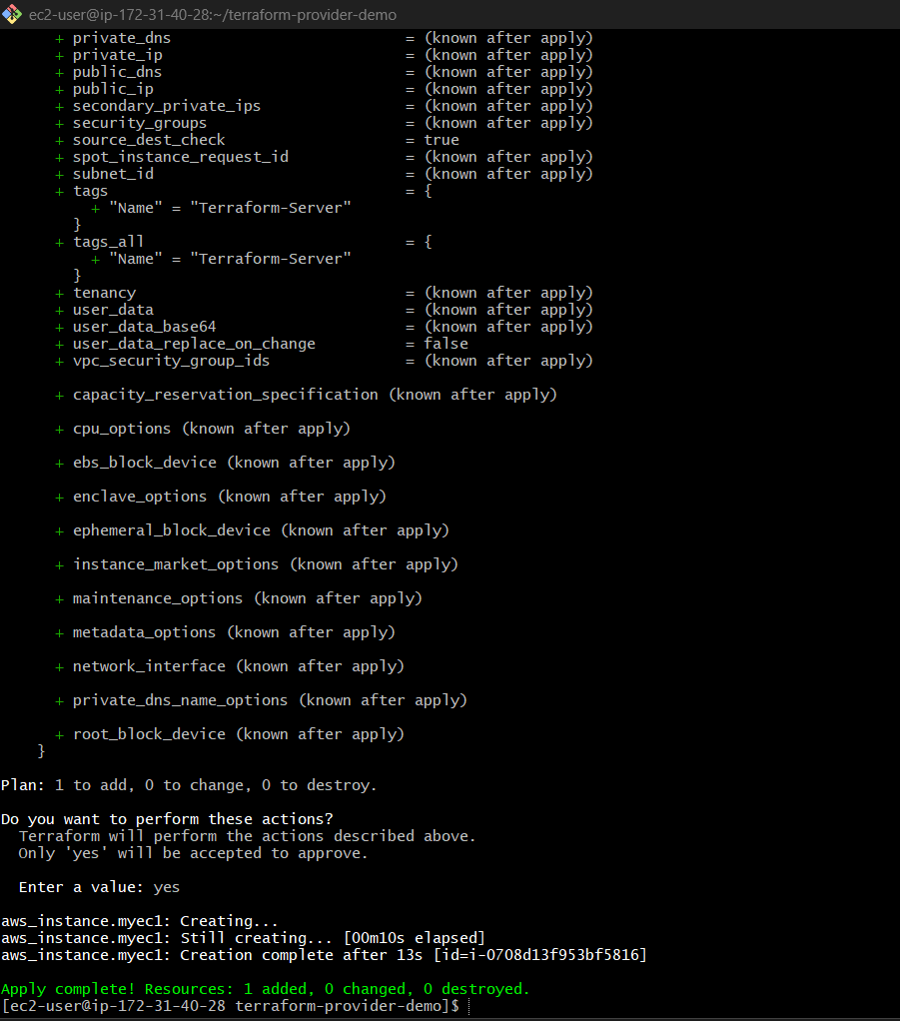
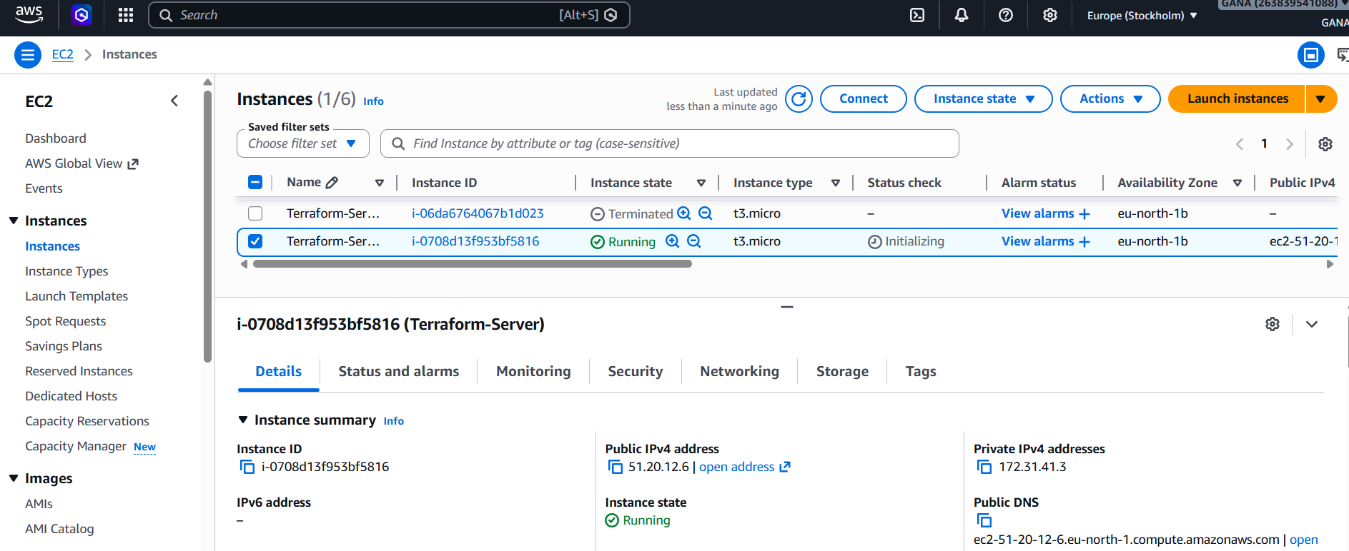

B) prevent_destroy
terraform {
required_providers {
aws = {
source = "hashicorp/aws"
version = "~> 5.0"
}
}
}
provider "aws" {
region = "eu-north-1"
}
resource "aws_instance" "myec1" {
ami = "ami-0b2ab3a97a77bd35e"
instance_type = "t3.micro"
lifecycle {
prevent_destroy = true
}
tags = {
Name = "Terraform-Server"
}
}

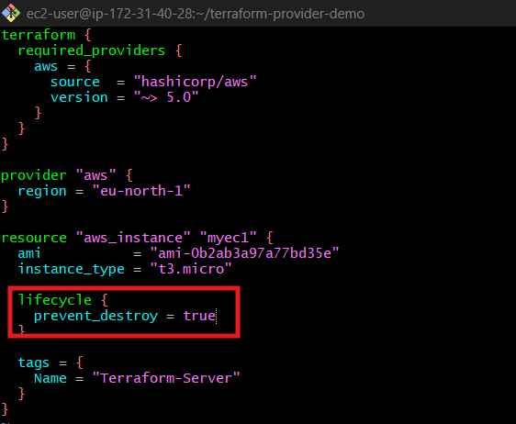

Plan
terraform plan

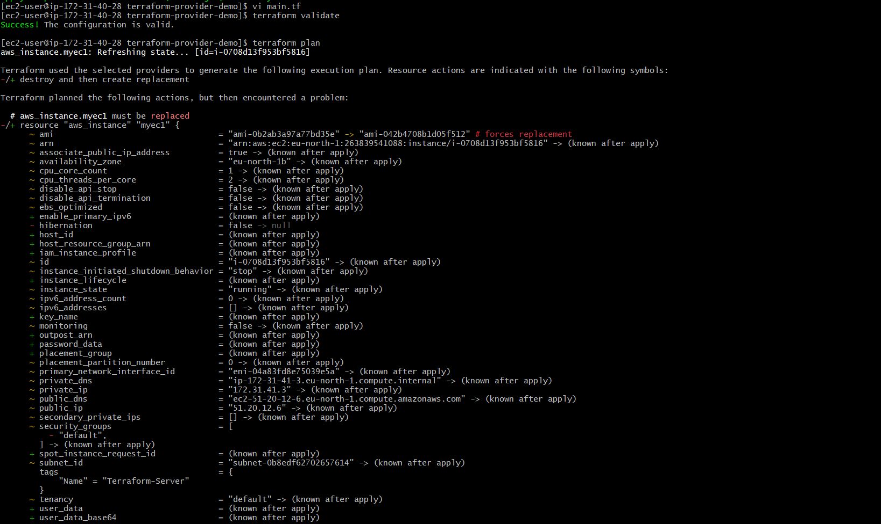
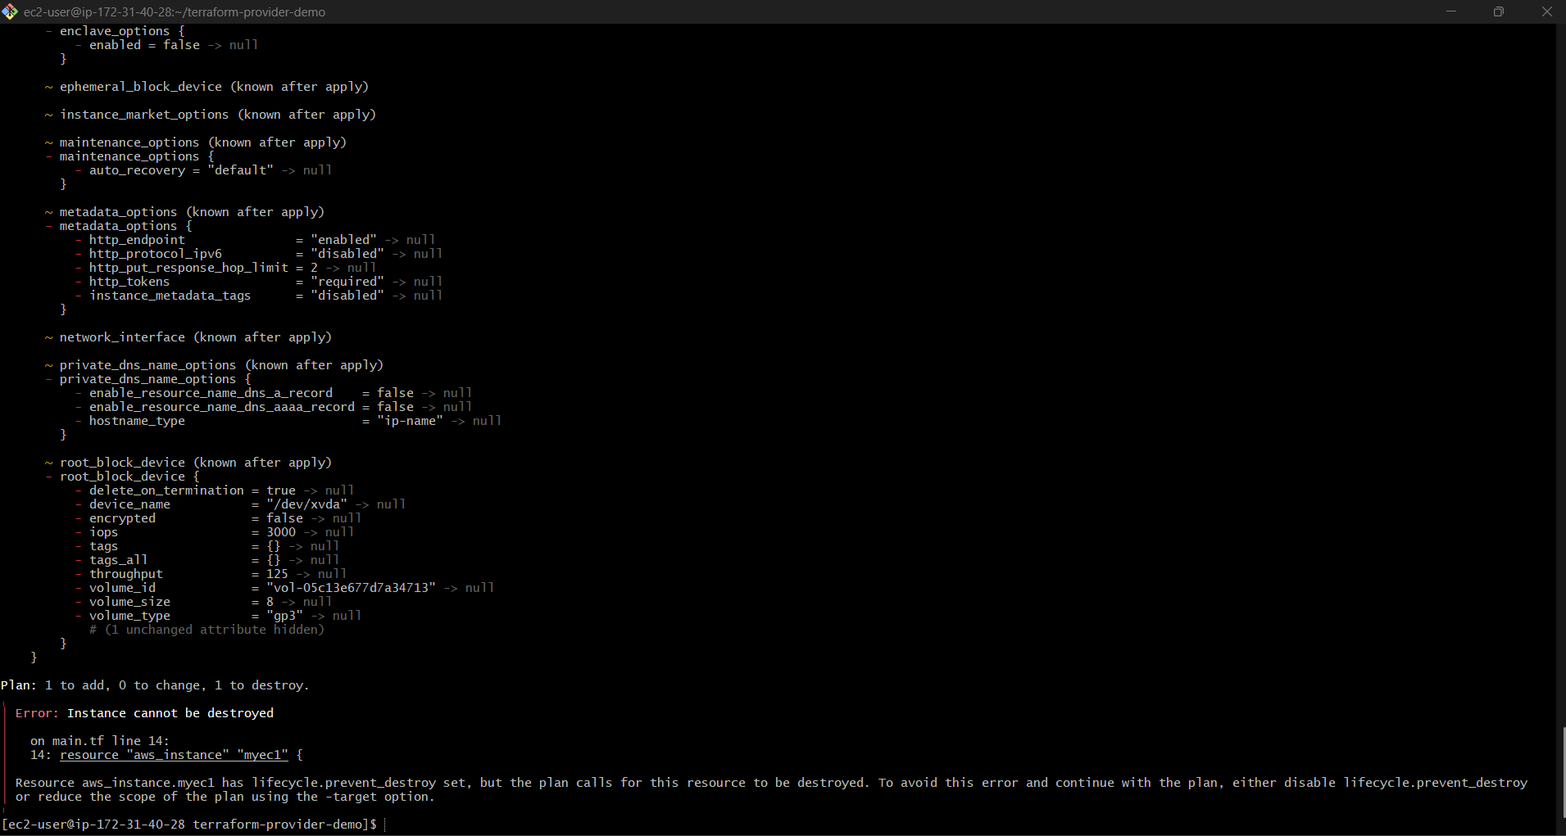

Apply
terraform apply

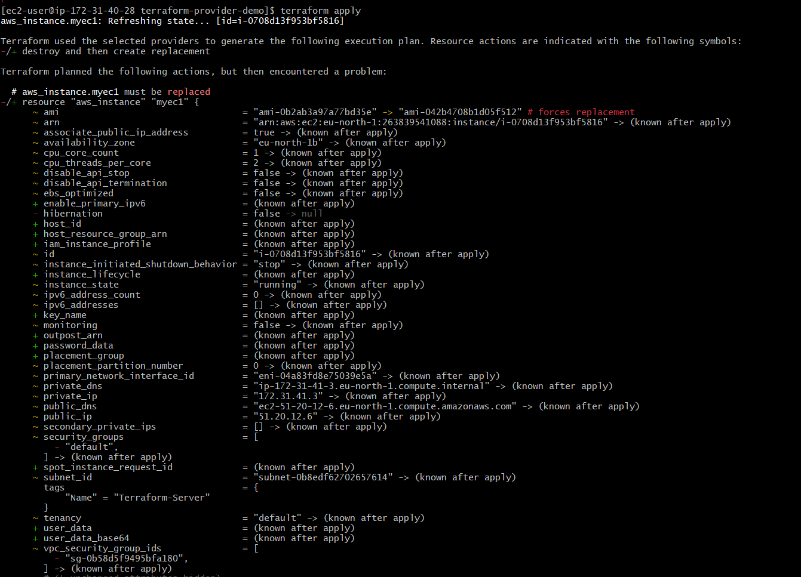
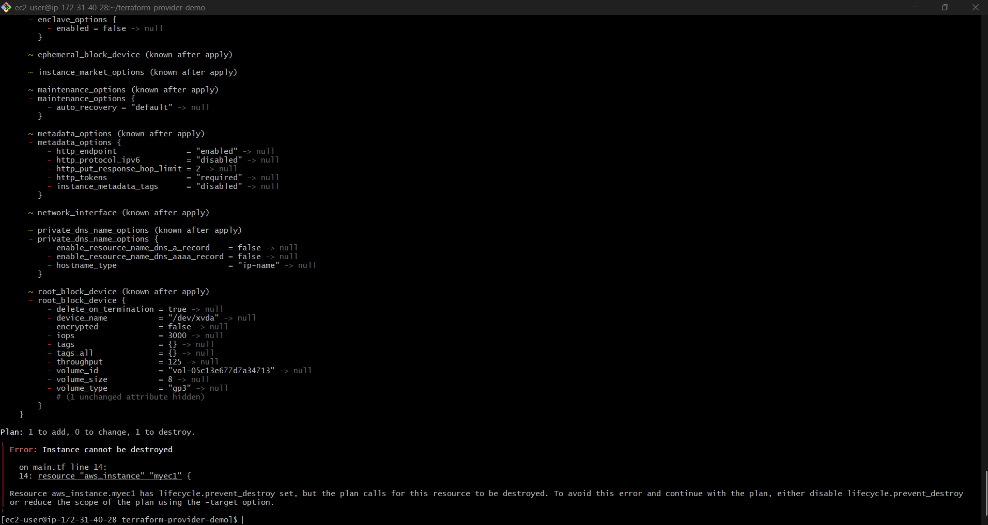
What prevent_destroy = true Does
This lifecycle rule protects your EC2 instance from accidental deletion.
Example:
If you run:
terraform destroy
Terraform will BLOCK deletion.
You’ll see an error like:
Instance cannot be destroyed
because prevent_destroy is set to true

Real-Time Production Use Case
Companies use:
prevent_destroy = true
for:
- Production databases
- Critical EC2 servers
- Important S3 buckets
to avoid accidental deletion.

To Allow Destroy Later
Either:
- Remove lifecycle block
OR
Change to:
lifecycle {
prevent_destroy = false
}
Then run:
terraform apply
terraform destroy

C) ignore_changes

terraform {
required_providers {
aws = {
source = "hashicorp/aws"
version = "~> 5.0"
}
}
}
provider "aws" {
region = "ap-south-1"
}
resource "aws_instance" "myec1" {
ami = "ami-0f5ee92e2d63afc18"
instance_type = "t2.micro"
lifecycle {
create_before_destroy = true
ignore_changes = [
tags
]
}
tags = {
Name = "Terraform-Server"
}
}

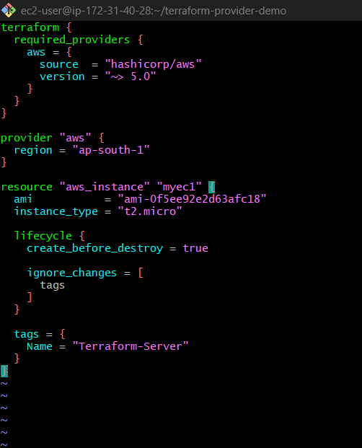

What This Does
create_before_destroy
create_before_destroy = true
Creates new EC2 first, then deletes old one.
Zero downtime ✅

ignore_changes
ignore_changes = [
tags
]
Terraform ignores manual tag changes.
Validate
Run:
terraform validate
Expected:
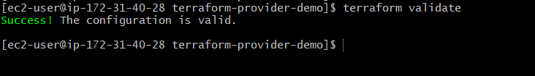
Success! The configuration is valid.
Apply
terraform apply
Type:
yes

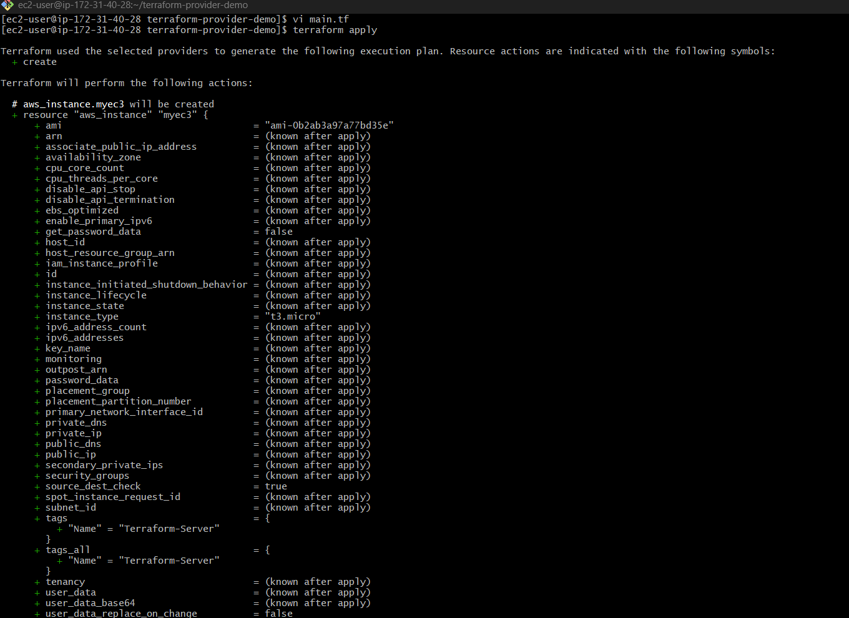
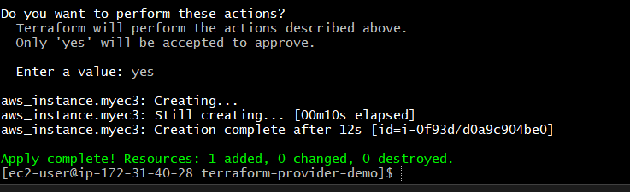

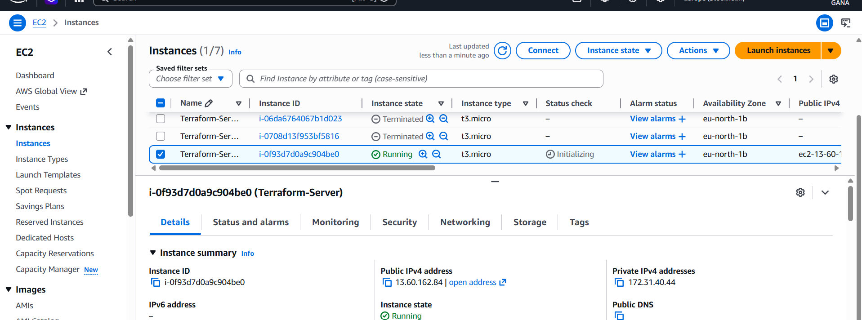

This creates EC2 instance in Amazon Web Services with both lifecycle rules enabled.
Real-Time Use Case
If DevOps team changes tags manually:
Terraform ignores those changes.

Template 1 — Local File Provider
Install provider automatically.
Create main.tf
terraform {
required_providers {
local = {
source = "hashicorp/local"
version = "2.4.0"
}
}
}
resource "local_file" "demo" {
filename = "sample.txt"
content = "Terraform Local Provider"
}
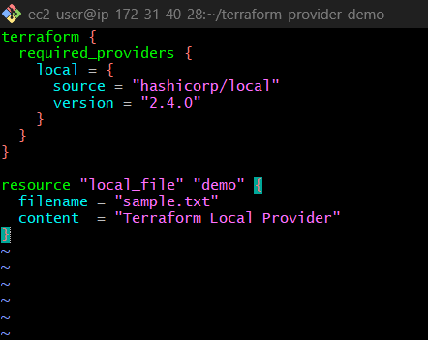
Execute:
terraform init
terraform plan
terraform apply
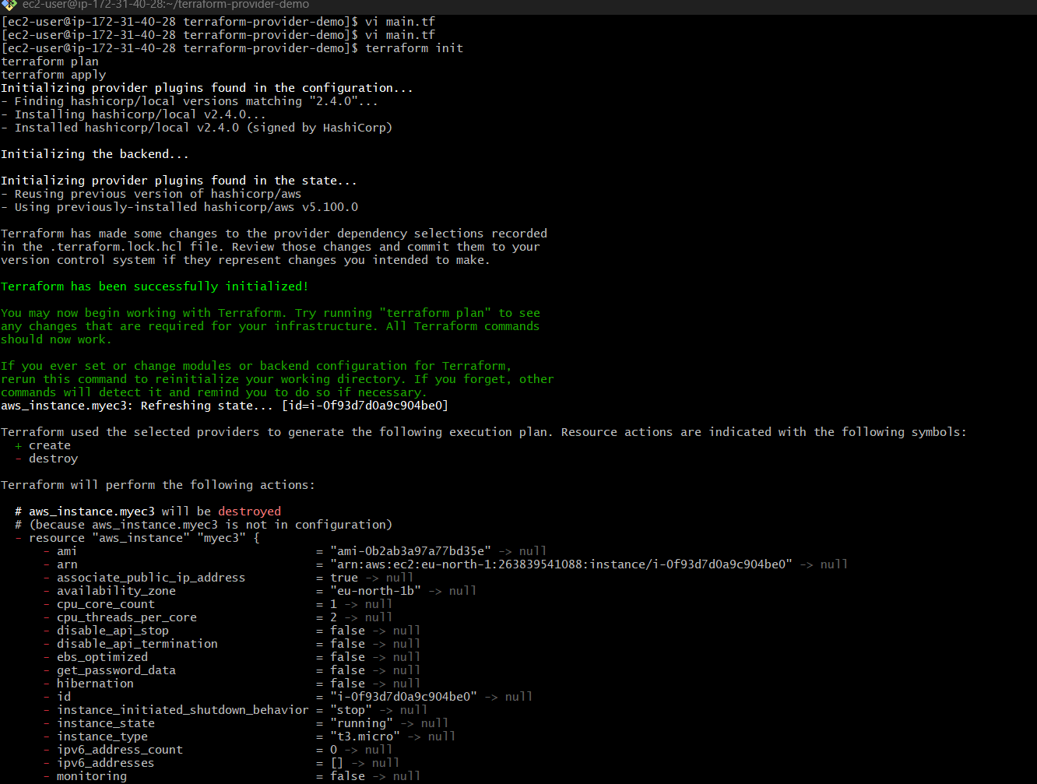
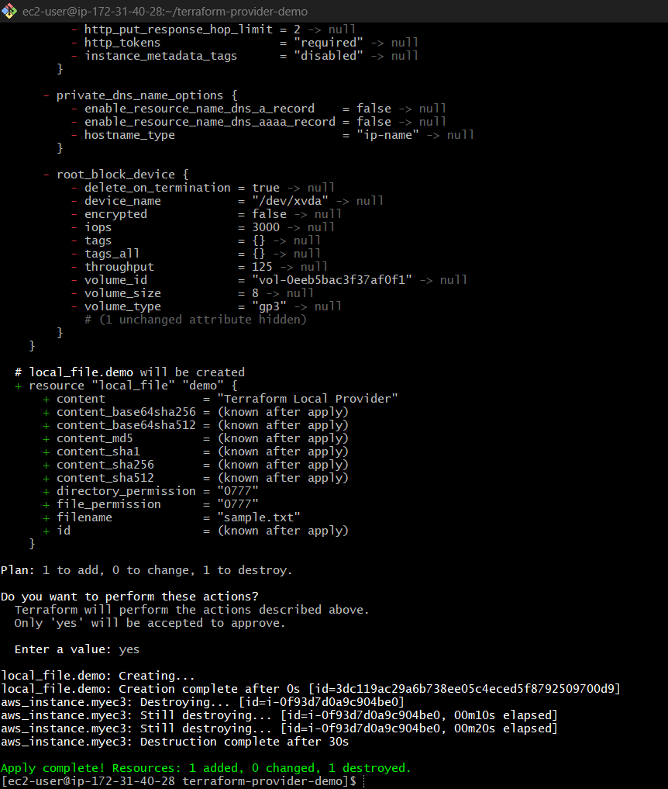

Template 2 — Random Provider
terraform {
required_providers {
random = {
source = "hashicorp/random"
}
}
}
resource "random_pet" "name" {
length = 2
}
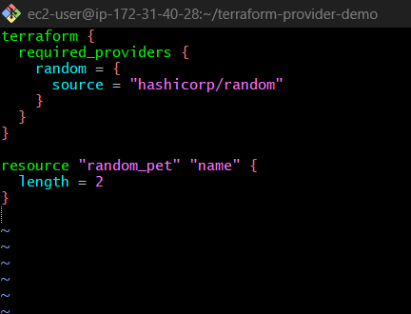
Run:
terraform init
terraform apply
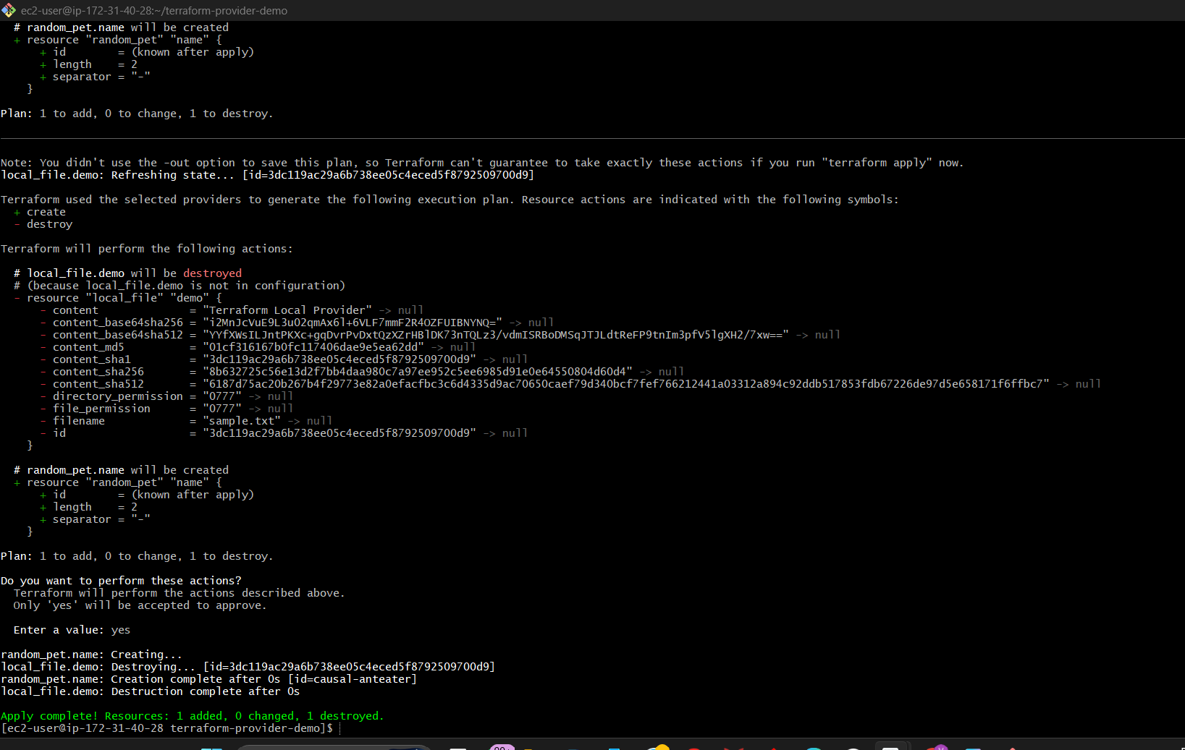

2 ) Integrate Terraform in Jenkins using the Terraform plugin.

Jenkins integration with Terraform allows:
- Automated infrastructure deployment
- CI/CD for infrastructure
- Auto provisioning

Architecture
Developer Pushes Code
↓
GitHub Repo
↓
Jenkins Pipeline
↓
Terraform Commands
↓
AWS Infrastructure

STEP 1 — Install Jenkins
Install Java first:
sudo yum install java-17-amazon-corretto -y
Add Jenkins repo:
sudo wget -O /etc/yum.repos.d/jenkins.repo \
https://pkg.jenkins.io/redhat-stable/jenkins.repo
Import key:
sudo rpm --import https://pkg.jenkins.io/redhat-stable/jenkins.io-2023.key
Install Jenkins:
sudo yum install jenkins -y
Start Jenkins:
sudo systemctl enable jenkins
sudo systemctl start jenkins
Check:
sudo systemctl status jenkins

STEP 2 — Install Terraform on Jenkins Server
Download Terraform:
sudo yum install -y yum-utils
sudo yum-config-manager --add-repo \
https://rpm.releases.hashicorp.com/AmazonLinux/hashicorp.repo
Install:
sudo yum -y install terraform
Verify:
terraform -version

STEP 3 — Install Terraform Plugin in Jenkins
Open Jenkins:
http://YOUR_PUBLIC_IP:8080
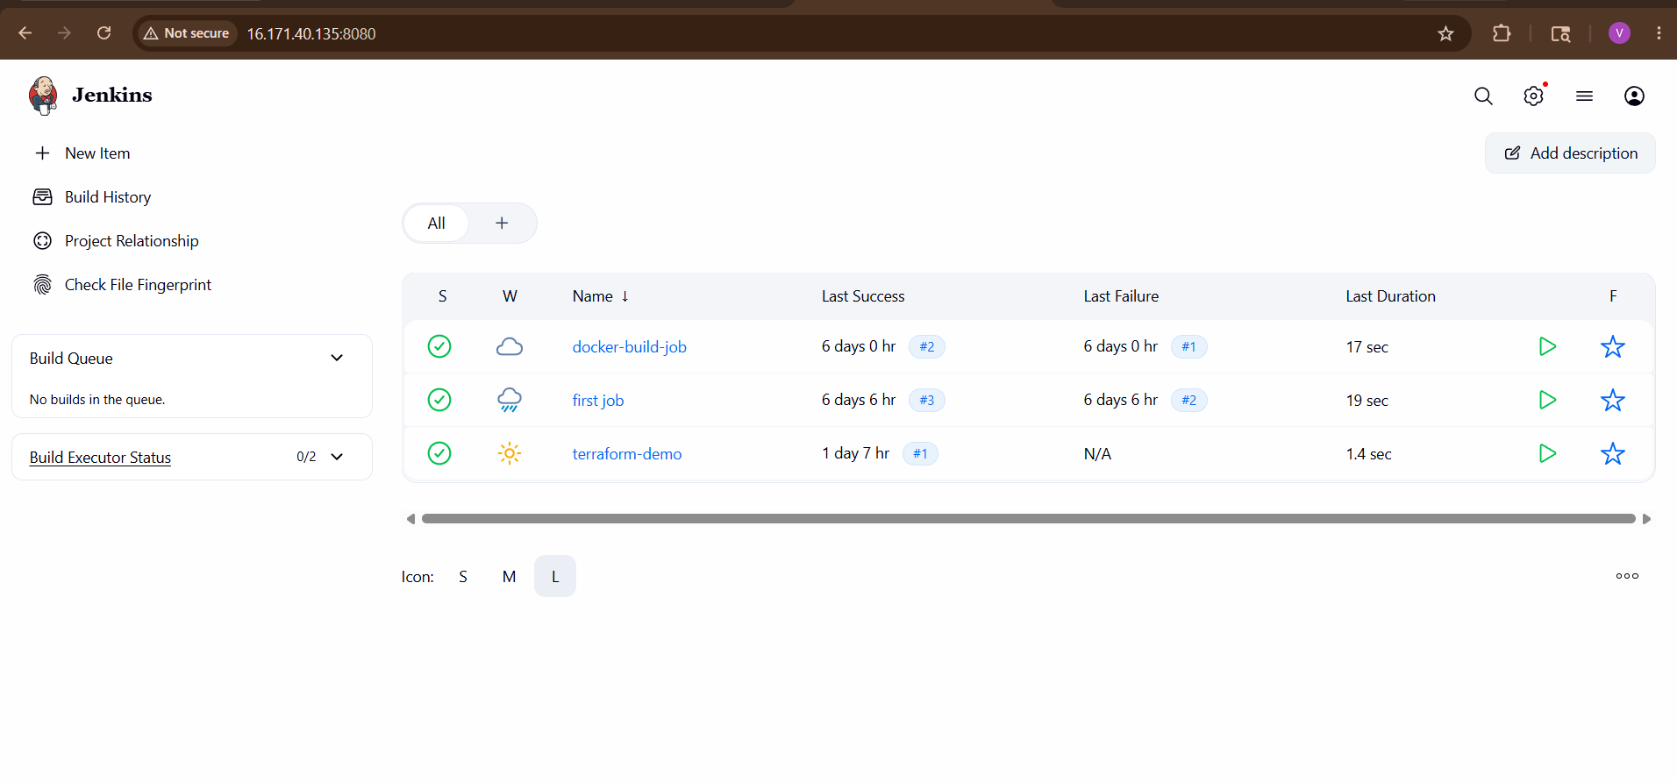Go to:
Manage Jenkins
→ Plugins
→ Available Plugins
Search:
Terraform
Install:
- Terraform Plugin
Restart Jenkins.
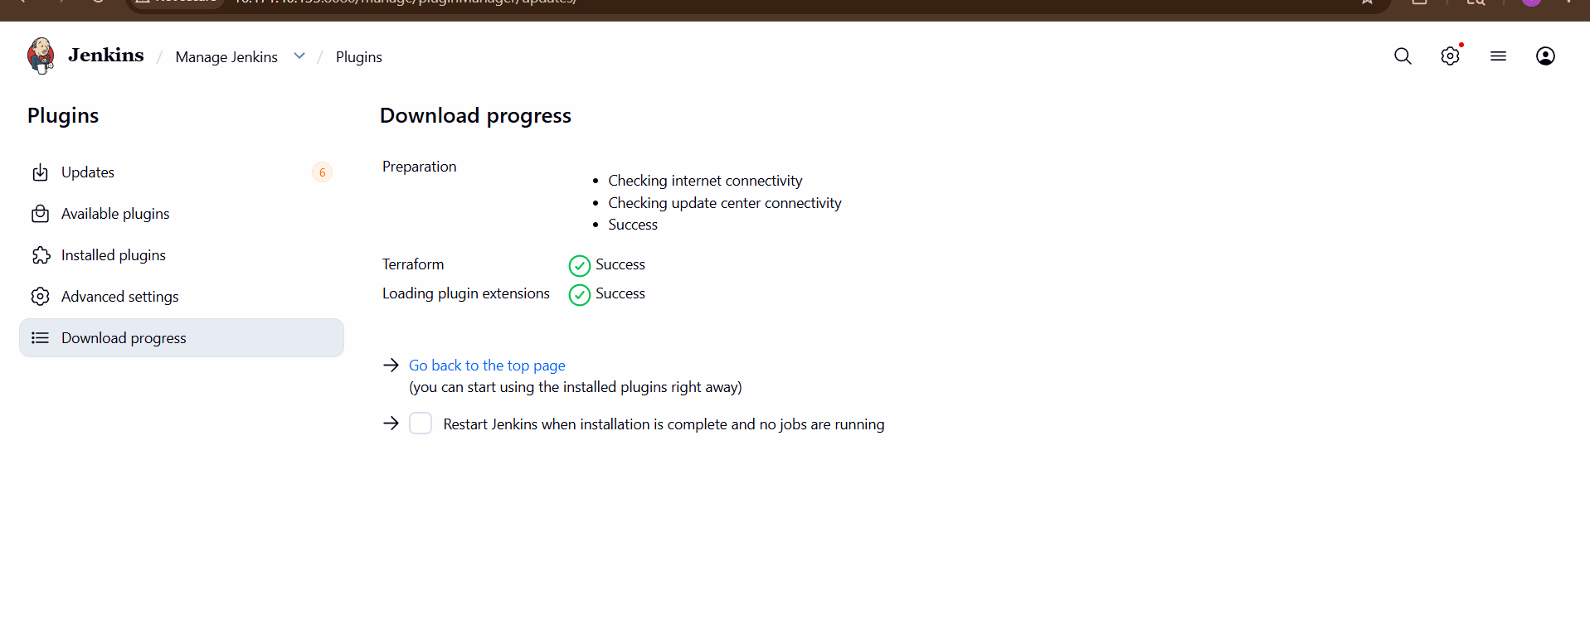

STEP 4 — Configure Terraform Tool
Go to:
Manage Jenkins
→ Tools
Find:
Terraform
Add:
Name: terraform
Install automatically: checked
Version: latest
Save.
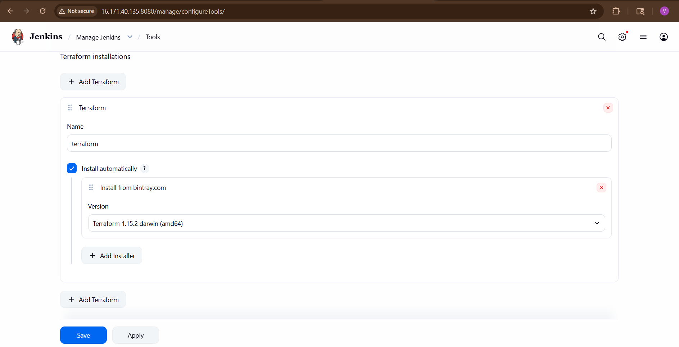

STEP 5 — Install AWS Credentials
On Jenkins server:
aws configure
Enter:
- Access key
- Secret key
- Region
Test:
aws s3 ls

STEP 6 — Create Terraform Project
Create directory:
mkdir terraform-demo
cd terraform-demo
Create main.tf
provider "aws" {
region = "eu-north-1"
}
resource "aws_instance" "demo" {
ami = " ami-0b2ab3a97a77bd35e"
instance_type = "t3.micro"
tags = {
Name = "JenkinsTerraform"
}
}
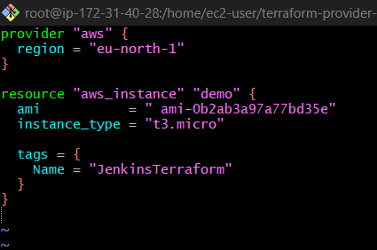

STEP 7 — Push Code to GitHub
Initialize Git:
git init
Add files:
git add .
git commit -m "terraform project"
Push to GitHub.
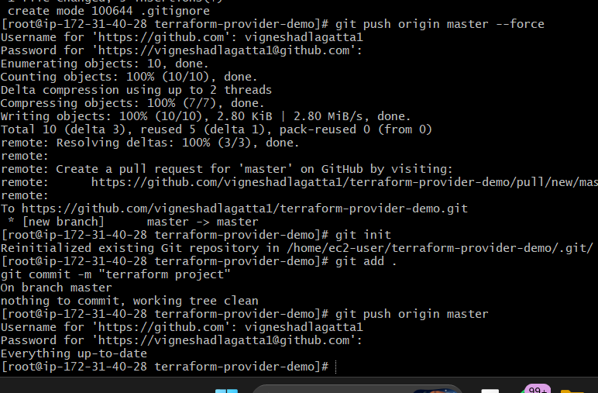

STEP 8 — Create Jenkins Pipeline Job
Go to:
New Item
Select:
Pipeline
Name:
terraform-pipeline
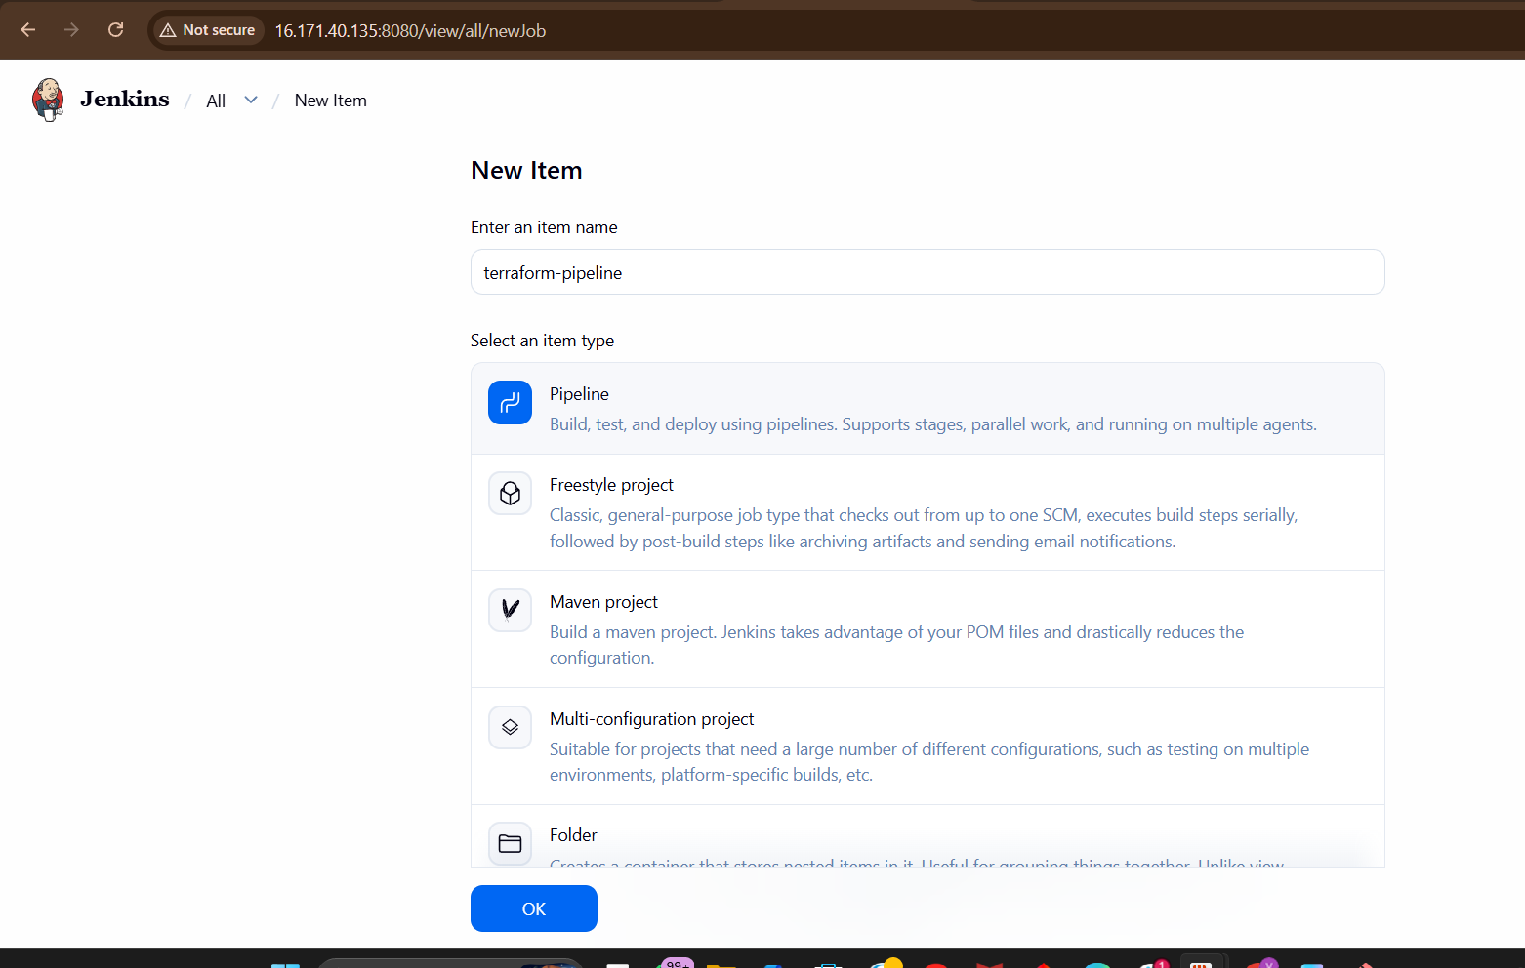

STEP 9 — Configure Pipeline Script
Add this Pipeline:

pipeline {
agent any
tools {
terraform 'terraform'
}
environment {
AWS_DEFAULT_REGION = 'eu-north-1'
}
stages {
stage('Clone Repo') {
steps {
git 'https://github.com/vigneshadlagatta1/terraform-provider-demo.git'
}
}

stage('Terraform Init') {
steps {
withCredentials([[
$class: 'AmazonWebServicesCredentialsBinding',
credentialsId: 'aws-creds'
]]) {
sh 'terraform init'
}
}
}
stage('Terraform Validate') {
steps {
withCredentials([[
$class: 'AmazonWebServicesCredentialsBinding',
credentialsId: 'aws-creds'
]]) {
sh 'terraform validate'
}
}
}
stage('Terraform Plan') {
steps {
withCredentials([[
$class: 'AmazonWebServicesCredentialsBinding',
credentialsId: 'aws-creds'
]]) {
sh 'terraform plan'
}
}
}

stage('Terraform Apply') {
steps {
withCredentials([[
$class: 'AmazonWebServicesCredentialsBinding',
credentialsId: 'aws-creds'
]]) {
sh 'terraform apply -auto-approve'
}
}
}
}
post {
success {
echo 'Terraform Infrastructure Deployment Successful!'
}
failure {
echo 'Terraform Deployment Failed!'
}
}
}
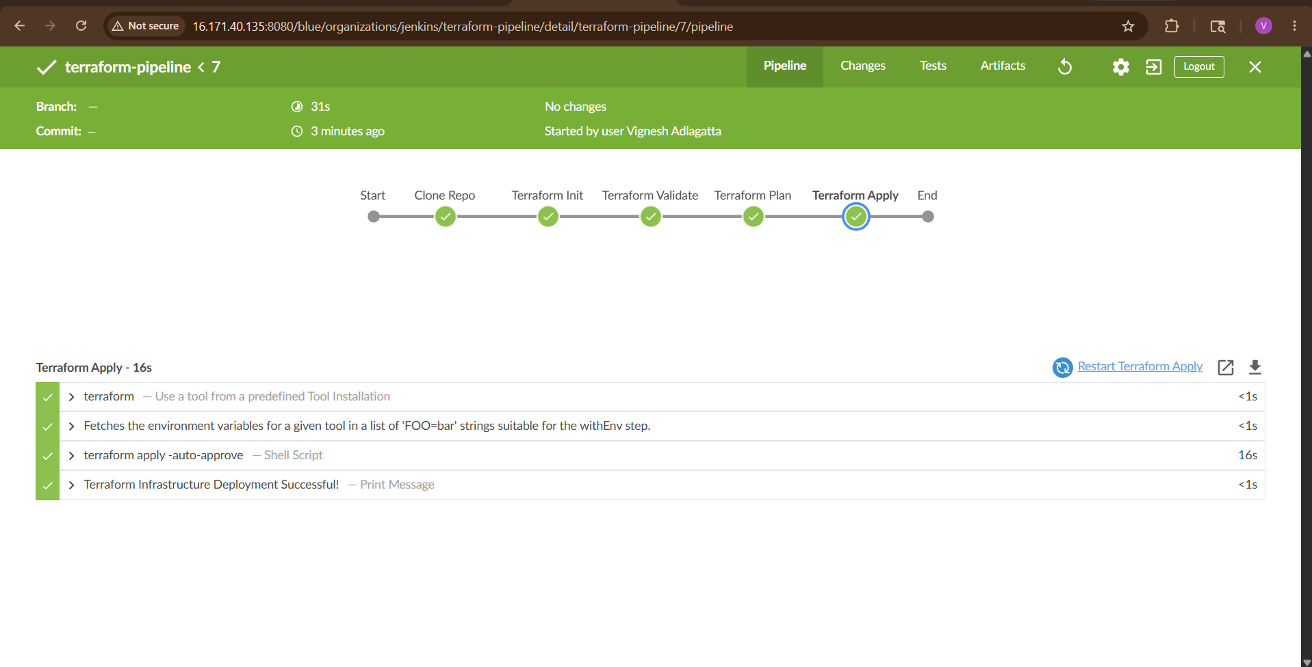
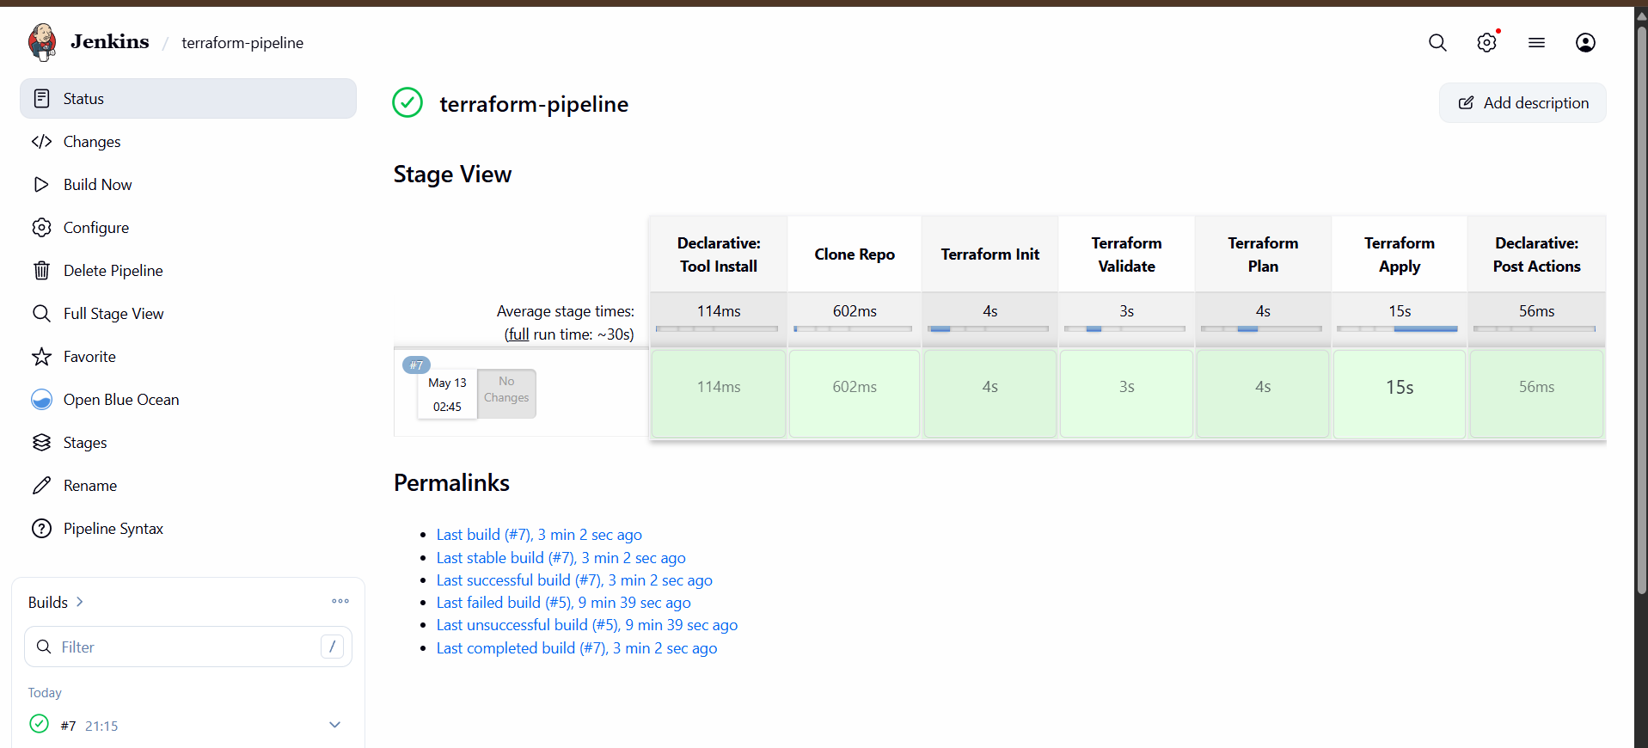

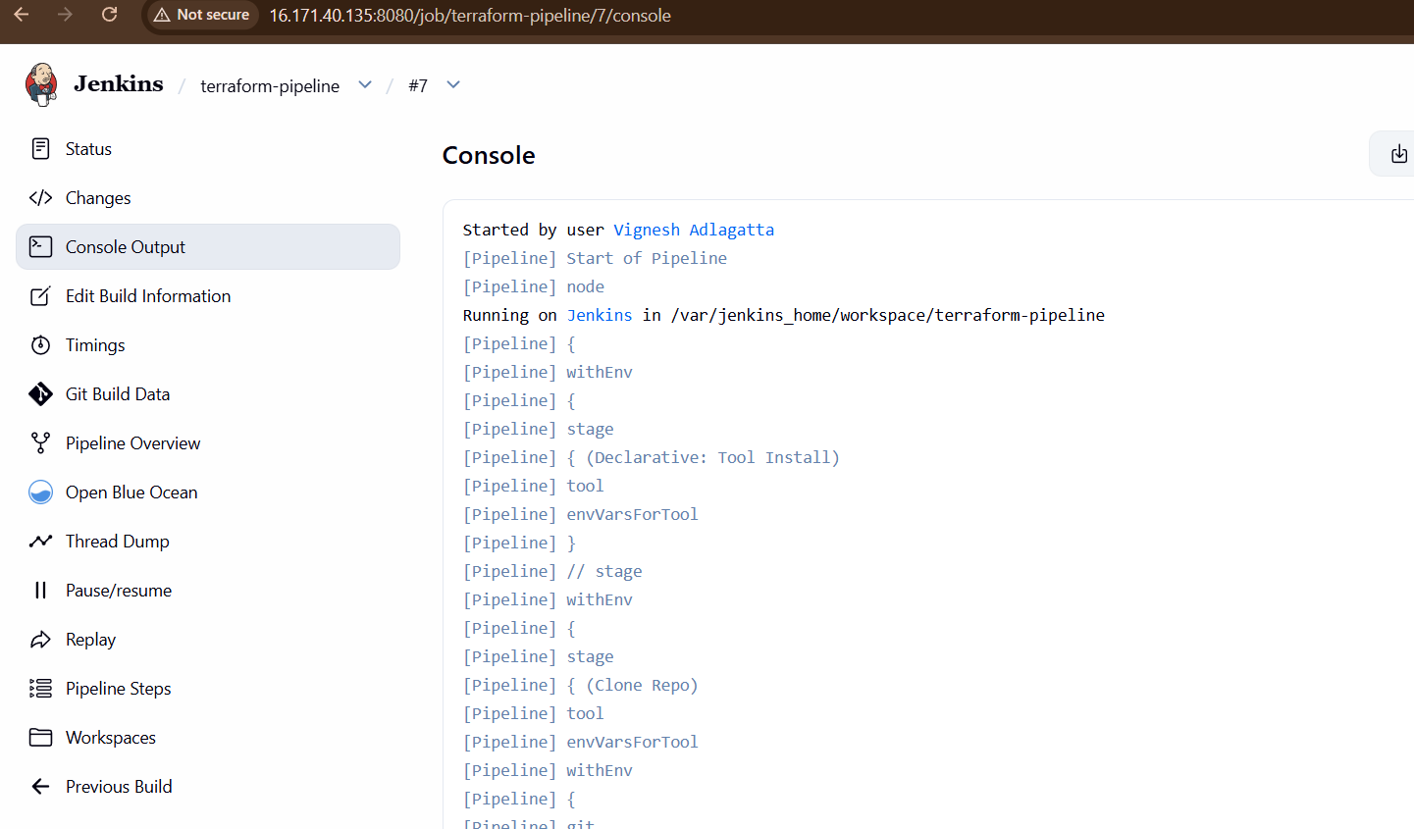
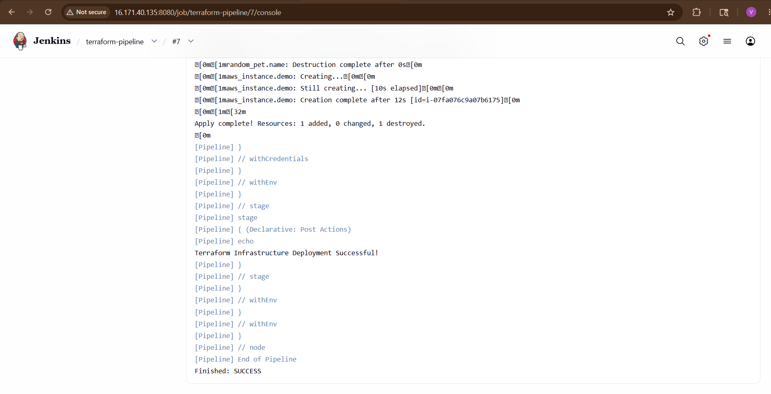
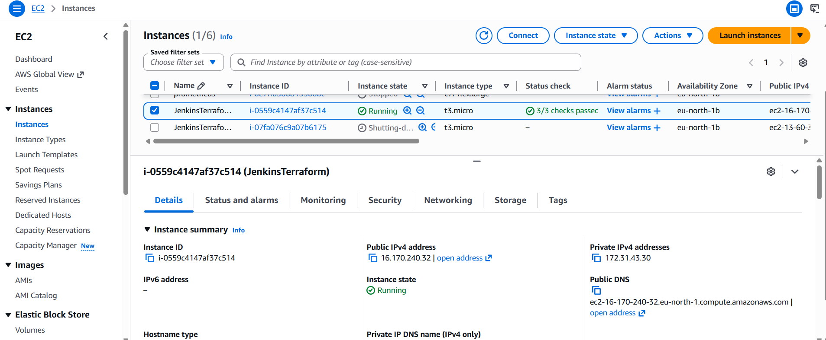

STEP 10 — Build Pipeline
Click:
Build Now
Pipeline automatically:
- Clones repo
- Initializes Terraform
- Validates code
- Creates execution plan
- Deploys infrastructure

What This Pipeline Does
Stage | Purpose
Clone Repo | Downloads Terraform code from GitHub
Terraform Init | Downloads providers/plugins
Terraform Validate | Checks Terraform syntax
Terraform Plan | Creates execution plan
Terraform Apply | Deploys infrastructure

Real-Time CI/CD Workflow
Developer Pushes Code
↓
GitHub Repository
↓
Jenkins Pipeline Trigger
↓
Terraform Init
↓
Terraform Validate
↓
Terraform Plan
↓
Terraform Apply
↓
AWS Infrastructure Created

Important Terraform Commands
Command |  |  | Purpose
terraform init |  |  | Initialize
terraform validate |  |  | Validate syntax
terraform fmt |  |  | Format code
terraform plan |  |  | Preview changes
terraform apply |  |  | Create infrastructure
terraform destroy |  |  | Delete infrastructure
terraform show |  |  | Show state
terraform output |  |  | Show outputs

